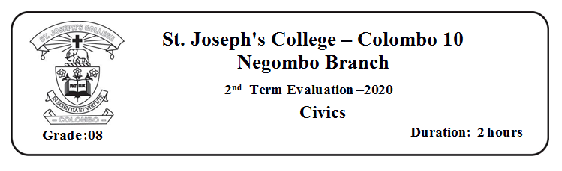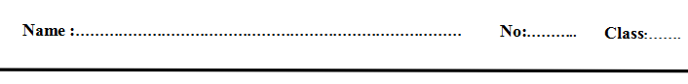

**01) Provide short answers**

1) Who is the father of free education?

2) What is the institution that distributes water?

3 ) What is the main duty fulfilled by police ?

4) What is the motto of the co-operative movement?

5) What is the organization that declared Sri Lanka as a malaria free country?

**02) Select the correct answer**

6)The year which passed the act of free education was,

i) 1948 ii)1947 iii)1945 iv)1946

7)The king who appointed a doctor for thousand villages was

i)King Dutugemunu ii)King Parakramabahu iii)King Elara iv) King Buddhadasa

8)___________ are considered as children according to United Nations Convention on Child Rights

i) Human beings below 18 years ii) Human beings below 14 years

iii)Human beings below 20 years iv)Human beings below 19 years

9) The public service which fulfills the diverse needs of people is

i) Police ii) School iii) Electricity iv) Co -Operative

10) The smallest social unit out of the following is

i) School ii) Family iii) Church iv) Temple

**03 Match each of the following sentence with the suitable word**

11) The most prevailing type of family in present day Suwadivi Center

12) The closest institution to a child other than family Competency Development

13) A responsibility fulfilled by an education institution School

14) An institution which provide security Police

15) The institution established to prevent non infectious diseases Nuclear

04 **Select and write the correct answer**

16) The institution that provides facilities to perform the tasks of a school in ordered manner is පා

17) The public service introduced in the time of british rule is

18) United Nations Children's Fund

19) A reaction that shows happiness

20) A reaction that shows fear

(widening of eye/ UNICEF/ Dancing /Divisional education office/ Transport//UNESCO /crying) (40 Marks)

**PART II**

**Answer four questions including the first**

* 1. What is the aim of providing a public service? ( 03 Marks)
  2. Name three public services that we use ? ( 03 Marks)
  3. Why do we need public services ? Give three reasons. ( 03 Marks)
  4. Write 3 common features of public services ( 03 Marks)
  5. Name a public service that you use and explain how it helps to improve your life ( 03 Marks)
  6. Name 3 duties of National Water Supply and Drainage Board ( 03 Marks)
  7. Name 3 functions of Health ( 03 Marks)
  8. Name 3 functions of education ( 03 Marks)
  9. Name two institutions that provide transport ( 02 Marks)
  10. Explain the benefits of becoming an active member of a literary society, sport society or religious society

( 04 Marks)

* 1. Write 3 responsibilities of Electricity board ( 03 Marks)
  2. Write 3 education providing institutions ( 03 Marks)
  3. Name two types of co-operatives functioning in sri lanka ( 02 Marks)
  4. Write two members of staff in Police ( 02 Marks)
  5. Write 3 responsibilities of people who use public services and explain one of them ( 05 Marks)
  6. What is a democratic society ? ( 02 Marks)
  7. Name 3 democratic features that can be seen in a family ( 03 Marks)
  8. Name 3 democratic features that can be seen in a family ( 03 Marks)
  9. Name 3 works that all the family members can participate ( 03 Marks)
  10. Name two co curricular activities that operate in a school ,Explain how they operate and the benefits you can gain from them ( 04 Marks)
  11. Name two child rights and two child responsibilities related to them ( 04 Marks)
  12. Name two institutions that work to protect child rights ( 02 Marks)
  13. Write two reactions to each of the following emotionsන්න ( 03 Marks)
      1. Happiness
      2. Sadness
      3. Fear
  14. Explain 3 methods to control bad emotions ( 06 Marks)
  15. Name 06 natural disasters ( 06 Marks)
  16. Write 04 things that we can do to prevent from natural disasters ( 04 Marks)
  17. Explain about the impact of tsunami disaster (05 Marks)